Objective Questions for chapter 4

- RE (a+b)* (aaa + bbb) (a+b)* This language may be accepted by the following GTG ?
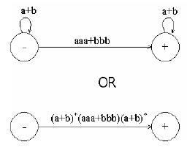
a. c.
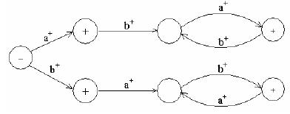

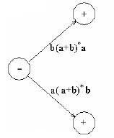
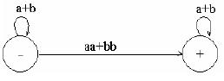
- d.

- Consider the language Kleene’s Theorem Part III, defined overΣ= {a,b}, consisting of only b, then this language may be accepted by the following FA ..
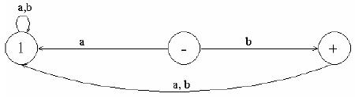
a.

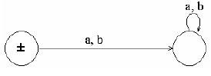
b.

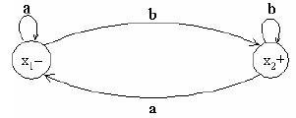
c.

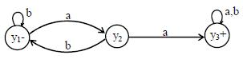
d.

- Consider the language L of strings, defined over Σ = {a,b}, containing double a or double b. The language L can be expressed by the following regular expression (a+b)* (aa + bb) (a+b)*
The language L may be accepted by the following GTG…
a.

b.

c.

d.

- If a language can be accepted by a TG then it can be expressed by an RE as well
This statement is Kleene’s Theorem Part ??
a. 1 b.2 c.3 d.4

- Which the true statement of Nondeterministic Finite Automaton (NFA) definition??
  - An NFA is a TG with a unique start state and a property of having single letter as label of transitions. An NFA is a collection of three things
  - Finite many states with two initial and some final states
  - Finite not set of transitions, showing where to move if a letter is input at certain state
  - there not more than one transition for certain letters and there may not be any transition for certain letters

- What the definition of Kleene’s Theorem Part I ?
  - If a language can be accepted by an FA then it can be accepted by a TG as well.
  - If a language can be accepted by a TG then it can be expressed by an RE as well
  - If a language can be expressed by a RE then it can be accepted by an FA as well
  - Since every FA can be considered to be a TG as well, therefore there is nothing to prove

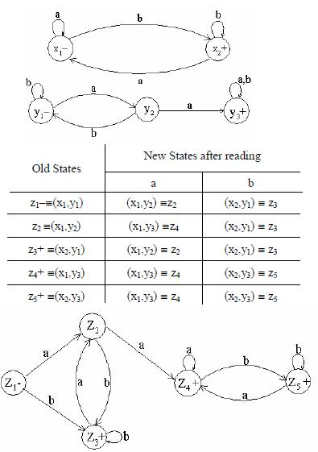

RE corresponding to the above FA is ?
- r1+r2 = (a+b)*b + (a+b )*aa(a+b )*.
- r1+r2 = (a+b)*b + (a-b )*aa(a+b )*.
- r1+r2 = aa(a+b)*b + (a+b )*aa(a+b )*.
- r1+r2 = (a+b)*b - (a+b )*aa(a+b )*.

- The examples of NFAs can be found in the following…
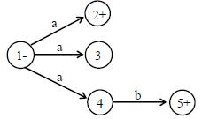
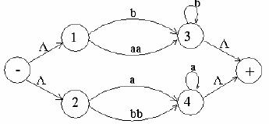
a. c.

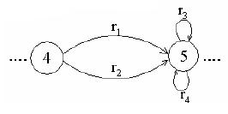
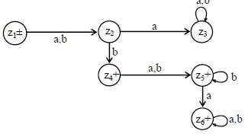
b. d.

- Consider the following TG
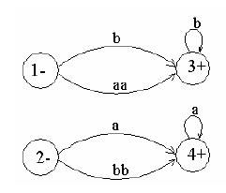

To have single initial and single final state the above TG can be reduced to the following..
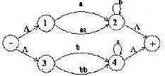
a. c.

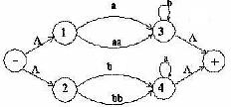
b. d.

10.

